Problem Description
- Problem Title:
  - SEIS 610 – Generic Programming (GP) Project
- Problem Summary:
  - Generating a function that is equivalent to the target function
- Detailed description:
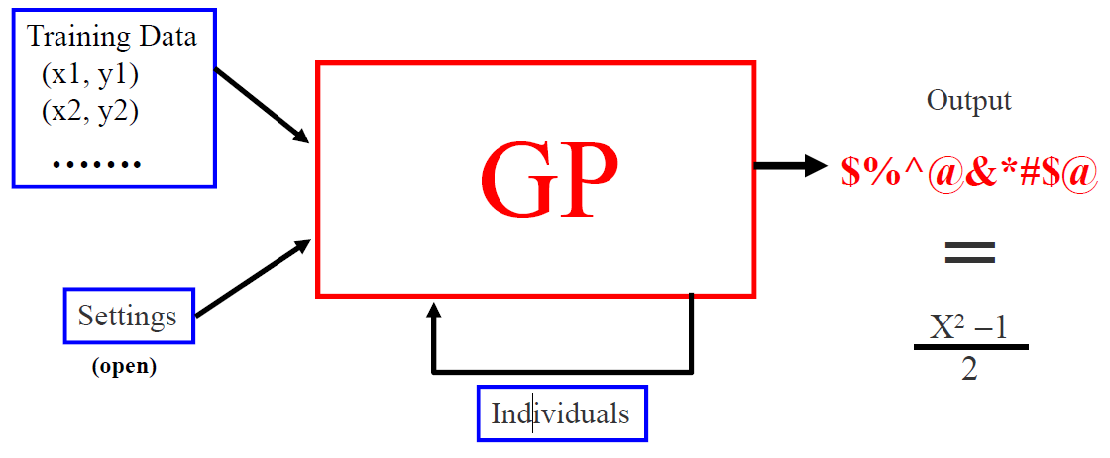
  - Generate a set of training set to evaluate the fitness. A set of random input (x) will be generated. Evaluate the input using the target function, to provide the training set.
  - Generate a set of initial inputs of random compositions of the function of the problem.
  - Execute each program in the population and assign it a fitness value according to how well it solves the problem. The fitness can be calculated as the delta (sum of error) of the function and the target function. Higher delta leads to a lower fitness.
  - If there is a function that meets the termination condition (delta =0), program stops.
  - If termination condition does not meet, the following steps will be executed
    - Natural Selection: The solutions with good fitness value survive to the next generation with high probability. Solutions will lower fitness value perish with high probability.
    - Crossover: Two solutions chosen with natural selection to generate new solutions
    - Mutation: replacing part of the solution with random generated new solution to reproduce new solutions
    - Repeat the fitness and selection step until termination condition meets, or time is over

- Approach
  - The project will follow the “V-module” during the software development.
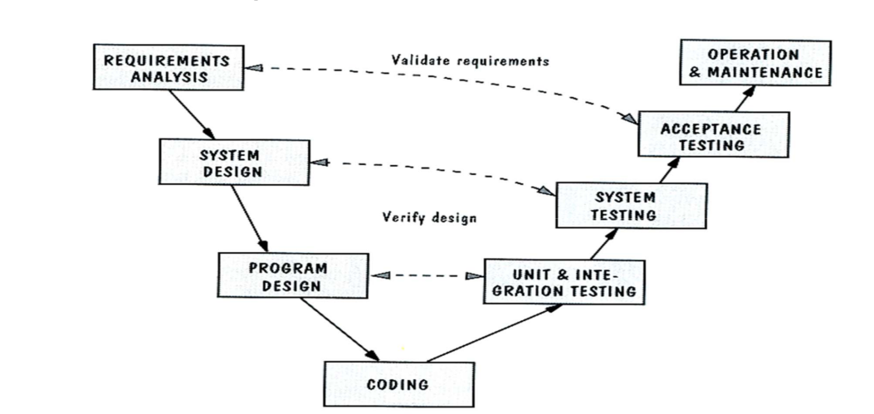
  - The client requirement should be documented and captured during the development

